Being a caregiver can be stressful at times. We're here to help. Whether you're caring for

a parent,
neighbor,
or friend learn how to make time for yourself, receive the advice and

encouragement you need and gain a new perspective.
DISCOVER:

- Stress management techniques
- Local resources available • New approaches to
caregiving

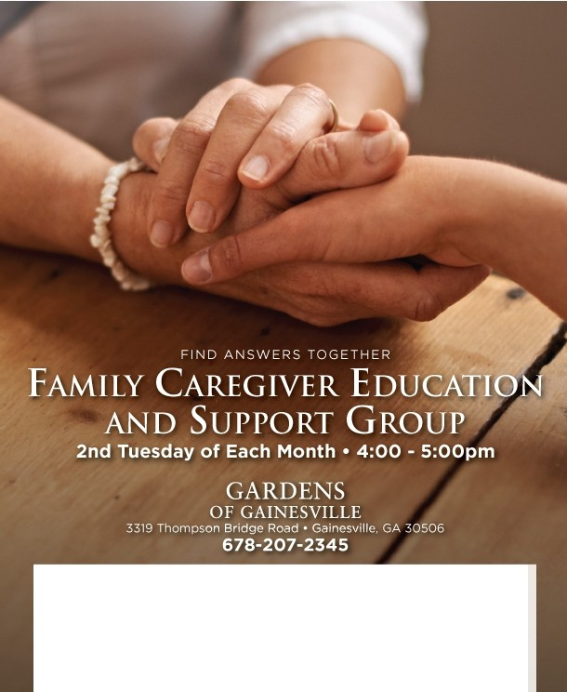
IIIVDU T.1111
Call 678-207-2345 for more information.
www.GardensOfGainesville.com
I ND EPE ND EN T LI V I NG • A SSISTED LI V I NG • MEM ORY C A RE
,::2, 01a Fw, SI¥ s,111orl wng

